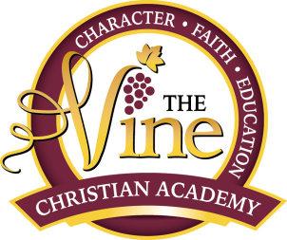
Transition School Supply List

- 1 Big see through or mesh back pack
- 1 Lunch Box (with 2 snacks and lunch)
- 1 Bible (ESV)
- 3 Composition notebooks
- 1 Pencil Box
- 3 Boxes of 24 #2 Pencils with erasers
- 2 Big Erasers
- 1 Box of colored pencils
- 1 Box of crayons (Crayola Brand)
- 1 Glue Stick
- 1 4 oz. Bottle of white school glue
- 2 clear tape rolls
- 1 masking tape roll
- 1 pencil sharpener that holds shavings
- 1 Ruler with centimeter and inch markers
- 4 Reams of copy paper
- 1 Pair of Scissors
- 2 Highlighting markers (any color)
- 1 white out or correction tape
- 2 packages of EXPO Dry Erase markers -any color
- 1 Black sharpie marker
- 1 Package of Play Dough (do not label)
- 1 Noise cancelling head phone/ear phones (If needed by the student)
- 2 hand Sanitizing Bottles
- 5 Packs of Lysol , Clorox or Disinfecting Wipes
- 2 Disinfectant Spray Bottles
- 4 Paper Towel Rolls
- 1 Pack of Baby Wipes
- 2 Packs of plastic spoons
- 3 Packs of plastic forks
- 1 Abacus (K- 5th students only)
- 1 Calculator (8th grade to High School)
- 2 folders with sleeves
- 1 Roll of craft paper (any color)
- 1 pack of paper plates
(Please label all materials with your child’s name)

